**8 SCIENCE 2016**

### BIOLOGY TEST TWO

Name: ______________________ Teacher (please circle): LAFFERTY/CERNY/NORGROVE/MILNER

Mark: /51

**Percentage: %**

**SECTION A: MULTIPLE CHOICE (15 marks)**

**Select the most correct answer for each question below.**

Please answer on the multiple choice answer grid below.

1. A B C D 10. A B C D

2. A B C D 11. A B C D

3. A B C D 12. A B C D

4. A B C D 13. A B C D

5. A B C D 14. A B C D

6. A B C D 15. A B C D

7. A B C D

8. A B C D

9. A B C D

**1.** Skin is also known as:

(a) Muscles.

(b) Epithelium.

(c) Diaphragm.

(d) Epiththorax.

**2.** Choose the correct definition for ‘bacteria’.

(a) Simple unicellular organisms that do not have a nucleus.

(b) Simple unicellular organisms that do have a nucleus.

(c) Simple multicellular organisms that do not have a nucleus.

(d) Complex multicellular organisms that do have a nucleus.

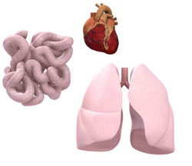**3.** The images on the right are all examples of:

(a) Tissues.

(b) Organs.

(c) Systems.

(d) Cells.

**4.** The cells that carry oxygen from the lungs around the body are known as:

(a) White blood cells.

(b) Oxygen blood cells.

(c) Red blood cells.

(d) Energy blood cells.

**5.** The largest organ in the human body is the:

(a) Large intestine.

(b) Skin.

(c) Lungs.

(d) Heart.

**6.** The two types of digestion are:

1. Chemical and muscular.
2. Chemical and mechanical.
3. Mechanical and hormone action.
4. Chewing and churning in the stomach.

**7.** The spleen is responsible for:

1. Filtering fluids
2. Helping the digestive system
3. Regulating blood sugar
4. Purifying the blood and fighting harmful bacteria

**8.** Tissues are found in multicellular organisms. Select the correct definition of tissues:

1. A group of cells of the same type working together.
2. Different organs working together to carry out a particular function.
3. A number of different cell types that make up an organ.
4. Another name for a system.

**9.** The kidneys are the main organ involved in excretion. Other organs are also involved. Which of the following are NOT involved in excretion?

1. Liver.
2. Heart.
3. Skin.
4. Lungs.

**Questions 10 – 13 refer to the diagram below.**

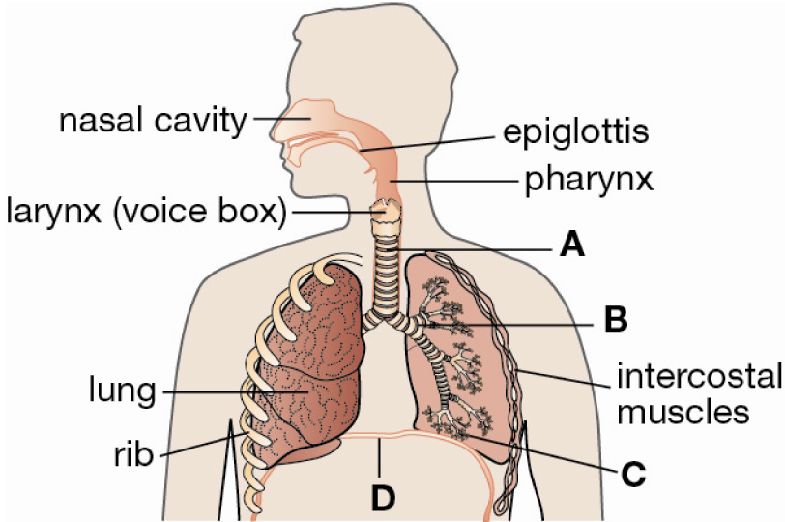

**10.** Label A refers to:

1. Alveoli.
2. Trachea/windpipe.
3. Bronchus.
4. Diaphragm.

**11.** Label B refers to:

1. Alveoli.
2. Trachea/windpipe.
3. Bronchus.
4. Diaphragm.

**12.** Label C refers to:

1. Alveoli.
2. Trachea/windpipe.
3. Bronchus.
4. Diaphragm.

**13.** Label D refers to:

1. Alveoli.
2. Trachea/windpipe.
3. Bronchus.
4. Diaphragm.

**14.** The most correct function of the nervous system is:

1. To initiate all of our movements.
2. To control the release of enzymes.
3. To send electrical impulses around the body.
4. To break down food.

**15.** Bile is released by an organ of the digestive system to help with the process of breaking down food. Where is bile produced?

1. The liver.
2. The pancreas.
3. The kidneys.
4. The small intestine.

**SECTION B: SHORT ANSWER (36 marks)**

1. Complete the table below by listing the four types of tissues found in the body and providing an example of each. (8 marks)

|  |  |
| --- | --- |
| Type of tissue | Specific example of where this type of tissue is  found in the body |
|  |  |
|  |  |
|  |  |
|  |  |

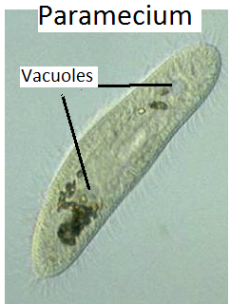**2.** Circle the term that best describes the organism on the right. (1 mark)

Multicellular Plant cell Unicellular Eukaryote

**3.** List the two types of blood cells in the body. (2 marks)

___________________________________________ ________________________________________

**4.** Write two examples of a multicellular organisms you would find at the zoo. (2 marks)

___________________________________________ ________________________________________

**5.** Explain the difference between unicellular organisms and multicellular organisms. (2 marks)

_____________________________________________________________________________________

_____________________________________________________________________________________

_____________________________________________________________________________________

_____________________________________________________________________________________

**6.** The diagram below shows the levels of organisation of the human body. (5 marks)

Identify the labels **A, B, C**, **D** and **E.**

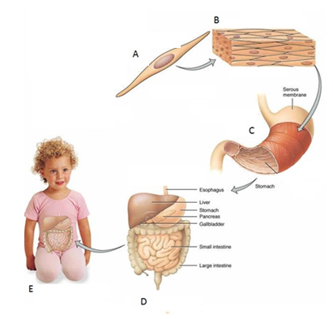

A: _____________________________

B: _____________________________

C: _____________________________

D: _____________________________

E: _____________________________

**7.** Determine if the following statements are true or false. (4 marks)

Many nerve cells grouped together are called nerve tissue. True False

Muscle tissue are not able to contract. True False

Tissues that add support and structure to the body are connective tissue. True False

Eggs in the female reproductive system are actually cells. True False

**8.** Fill in the empty boxes in the table below. (12 marks)

|  |  |  |
| --- | --- | --- |
| Name of system | **One** sentence that describes the main function  of the system | **One** example of an  organ in the system |
|  | Digests food. |  |
| Nervous system. |  |  |
|  |  | Ovaries |
|  | Gets oxygen from the air into the lungs and  gets rid of waste carbon dioxide. |  |
|  |  | Bone. |
| Excretory system. |  |  |